**UNIVERSITY OF ASIA PACIFIC**

Department of Computer Science & Engineering



**Artificial Inteligence Lab**

**Course Code: CSE 404**

**Assignment -1**

|  |  |  |
| --- | --- | --- |
|  |  |  |
| **Student Name** | : | Md. Sohanuzzaman Soad |
| **Student ID** | : | 18101064 |
| **Section** | : | B1 |
| **Date of Submission** | : | 18.08.2021 |

**Problem Statement:** Develop a program to represent your family tree in Prolog. Also show the relationship.

**Used Tools :** SWI - Prolog

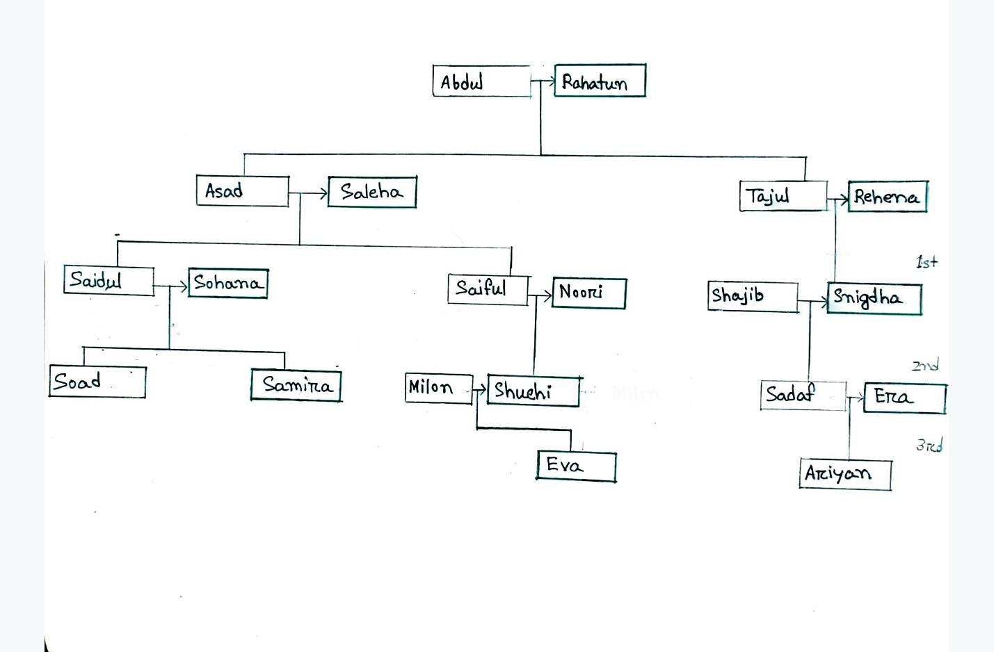

Fig: Family Tree

**Output:**

